
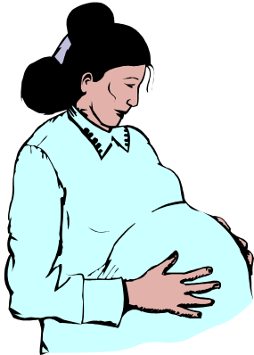
Pregnancy and
Gum Disease

OLD WIFE’S TALE: You will lose a tooth for every baby.

TRUTH: Infection in your gums may cause your baby to be born too soon or too small!!

If your gums bleed, or are red and swollen, you may have gum disease (periodontal disease).

Scientists are finding that when a pregnant woman has periodontal disease she may be 7 times more likely to have her baby too early!!

Even if you don’t have any signs, you could still have gum disease. It is important to go to the dentist as soon as you know you are pregnant.

A healthy mouth could make a big difference to your baby.

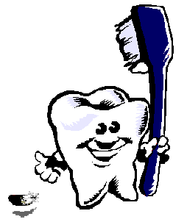

Inter Tribal Council of Arizona, Inc. - Dental Clinical and Prevention Support Center
2214 North Central Avenue, Suite 100, Phoenix, Arizona 85004
Phone: 602-307-1576 Fax: 602-258-4825

